https://driventowrite.com/2017/10/07/1997-ford-puma-design-insiration/#more-40805

Barchetta to Bobcat
Ford’s pre-millennial coupé didn’t gestate in an Erlenmeyer flask, but it was something of an amalgam nonetheless. We take a look at the Puma’s moodboard.
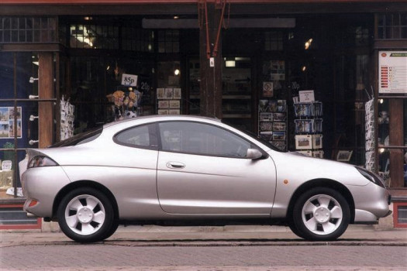
Production Puma in the inevitable Moondust Silver. Image RAC
The design theme for the 1997 Ford Puma bridged the blue oval’s early ’90s ovoid, organic design era and the ‘New Edge’ theme which arrived at the dawn of the millennium. But the roots of the Puma programme lie deeper.
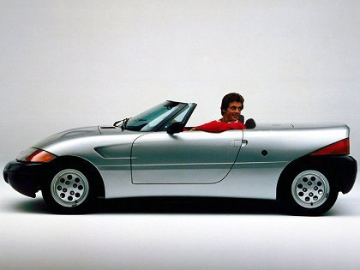
1983 Ghia Barchetta. Image TTAC
Although more in spirit than in form, the 1983 Ghia Barchetta was an early sign that Ford’s European outpost – then helmed by American, Bob Lutz – was interested in producing a more overtly sporting Fiesta variant. Based on Fiesta running gear, the pretty little Barchetta, styled in Fillipo Sapino’s Turin Ghia studio was first shown at that year’s Geneva show, had Lutz’s firm backing and it’s believed that serious thought was given to it being developed for production.
But in the classic multinational narrative, a promising concept was progressively watered down over time so that by the time Ford launched a car in this idiom – 1991’s Mazda-inspired Mercury Capri – it was not only a pale shadow of the 1983 concept, but more decisively, Mazda’s own game-changing MX-5 of 1989 batted it firmly into the touchlines and historical obscurity.
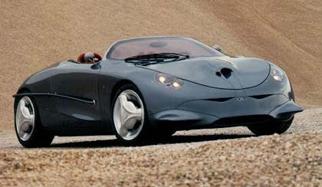
1992 Ghia Focus. Image: bestcars
The next hint as to what was to come down the line arrived in 1992 with the Taru Lahti designed Ghia Focus concept. While still very much a ‘barchetta’ shape, the Focus’ married voluptuous forms, anthromorphic detailing and a retro aesthetic reminiscent of Bertone’s 1950s BAT cars, proving hugely influential, not least upon Ford’s Köln-Merkenich styling studios. One can clearly see aspects of the eventual Puma in some of the surfacing, the treatment of the lower front facia and in the curved decorative bar which runs along the rear quarter flanks.
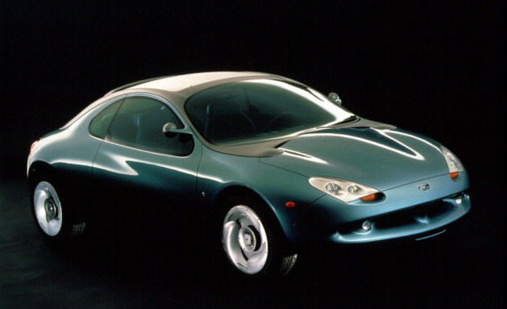
1994 Ghia Arioso concept. Image: carstyling.ru
A further signpost to Ford’s intentions came in 1994 in the form of the Ghia Arioso concept. Based on Mondeo underpinnings, and therefore a larger vehicle; nevertheless, many of the styling themes which would ultimately manifest themselves in the Puma were present – (particularly in the canopy area) – even if it was more North American Ford in overall execution and perhaps, intent.
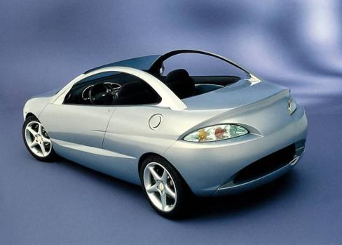
1996 Ghia Lynx concept. Image: carstyling.ru
The 1996 Geneva motor show saw the first showing of Ghia’s Lynx concept, a more overt foretaste of the coming Puma, then only a year away. Most likely designed after the Puma design was completed, if one ignores the canopy treatment – (such as it is) – the bulk of the production car’s style was laid bare. One surprising omission from the Puma programme was the option of a convertible version. The Lynx concept therefore suggests how such a car could have looked – not bad at all one could conclude.
While the Puma is generally regarded as a New Edge design, it is in fact a clever amalgam of several Ford design eras, a comparatively rare example of a car design marrying a number of different themes into an integrated, attractive and broadly well executed whole. The level of creativity being displayed in Ford’s various styling studios in the US, Germany and Italy during this period is quite notable. The great pity is that how little of that styling talent remains in evidence today.

